# Stakeholder Management

Stakeholder Management comprises of the methods required to classify the people, teams and departments that could affect or be affected by the project, to examine stakeholder potentials and their impact on the project, and to develop suitable plans and policies for effectively engaging stakeholders in line with the stakeholders’ interest and participation in the project. The Stakeholder Management Plan helps ensure that stakeholders are effectively involved in project decisions and execution [PMBOK 5th Edition] throughout the lifecycle of the project, to gain backing for the project and expect confrontation, clash, or opposing objectives among the project’s stakeholders. The Stakeholder Management Plan includes several sections [PMBOK 5th Edition]:

* **Identify Stakeholders** – identify by name and title the people, teams, and departments that have significant effect on project course and its accomplishment or who are considerably impacted by the project.
* **Plan Stakeholder Management** – identify the strategies and mechanisms that will be used to achieve the greatest support of stakeholders and minimize struggle.
* **Manage Stakeholder Engagement** – outlines the procedures and steps that will be undertaken to carry out the intended strategies.
* **Control Stakeholder Engagement** – describes the methods that will be used to monitor stakeholder engagement and alert the project team if problems are sprouting.

# Identify Stakeholders

In order to develop an effective plan for managing stakeholders, they first need to be identified and evaluated. Stakeholders needs to be identified by carrying out a stakeholder analysis in which potential stakeholders and relevant information (interests, involvement, interdependencies, influence, and potential impact on project success) are gathered, documented and analyzed. [PMBOK 5th Edition].

The Stakeholder Analysis Register should typically capture the following information

* Team / Group Name
* Number of Stakeholders in the Group
* Description of the Team / Group
* Level of Impact on the Project
* Issues, Opportunities and Risks associated with each group
* Strategies and Actions to address issues, risks and opportunities

A snapshot from the Stakeholder Analysis Register is provided below.

Please note: Impact is measured by High (H), Medium (M) or Low (L). State of change readiness is assessed using the measures from PMBOK as follows:

U – Unaware – this group has no information about the project

R – Resistant – aware of project and resistant to the changes and impacts the project may bring

N – Neutral – aware of the project and neither supportive nor resistant

S – Supportive – aware of the project and the potential changes and impacts and is supportive

L – Leading – aware of the project and actively engaged to ensure the project’s success

***Stakeholder Analysis Register sample table:***

|  |  |  |  |  |  |
| --- | --- | --- | --- | --- | --- |
| **Stakeholder** | **Unaware** | **Resistant** | **Neutral** | **Supportive** | **Leading** |
|  |  |  |  |  |  |
|  |  |  |  |  |  |
|  |  |  |  |  |  |

## Stakeholder Power/Interest Classification

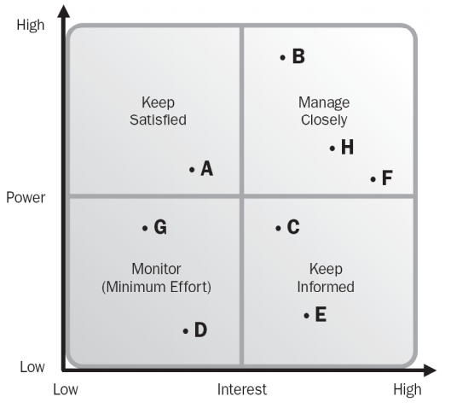An important result of the stakeholder identification and analysis work, including the Power/Interest Grid, is to classify the most influential and most impacted stakeholder groups so that a focused stakeholder management strategy and plan can be developed and executed.

Figure: Sample Stakeholder classification matrix

# Plan Stakeholder Management

Plan Stakeholder Management is the process of developing appropriate management strategies to effectively engage stakeholders throughout the lifecycle of the project, based on the analysis of their needs, interests and potential impact on project success. The key benefit of this process is that it provides a clear, actionable plan to interact with project stakeholders to support the project’s interests (PMBOK 5th Edition).

Based upon the information gathered in the Stakeholder Analysis Register and Communication Plan, the Project Manager will be responsible for engaging stakeholders through the lifecycle of the project. The level of engagement compulsory for each stakeholder may vary over the development of the project. For example, during the beginning stages of the project, it might be essential for the Project Manager to involve key stakeholders. Highly engaged key stakeholders in the early stages of the project are pivotal for project kickoff, achieving staff buy-in and clearing obstacles. As the project progresses, the level of engagement tend to shift from key stakeholders to the broader project team and end-users.

# Manage Stakeholder Engagement

Stakeholder Engagement Management is the process of communicating and working with stakeholders to meet their needs and expectations, and to address issues as they occur. Stakeholder Engagement Management is the process to methodically substitute appropriate stakeholder engagement in project activities throughout the life of the project. The key benefit of this process is that it allows the Project Manager to increase support and minimize resistance from stakeholders, significantly increasing the chances to achieve project success [PMBOK 5th Edition].

# Monitor Stakeholder Engagement

Monitor Stakeholder Engagement is the process of monitoring overall project stakeholder relationships and adjusting strategies and plans for engaging stakeholders. Monitor Stakeholder Engagement involves collecting data, assessing the level of engagement and using insights from the data collection to adjust strategies and tactics for engaging effectively with stakeholders.